**Faculty Member: Date:** .

**Semester: Section:** .

**EE-351 Communication Systems**

**Lab 7:**  **SSB TRANSMISSION**

|  |  |  |  |  |  |  |
| --- | --- | --- | --- | --- | --- | --- |
|  |  | **PLO4-CLO3** | | **PLO5-CLO4** | **PLO8-CLO5** | **PLO9-CLO6** |
| **Name** | **Reg. No** | **Viva / Quiz / Lab Performance** | **Analysis of data in Lab Report** | **Modern Tool Usage** | **Ethics and Safety** | **Individual and Team Work** |
|  |  | **5 Marks** | **5 Marks** | **5 Marks** | **5 Marks** | **5 Marks** |
|  |  |  |  |  |  |  |
|  |  |  |  |  |  |  |
|  |  |  |  |  |  |  |

**Lab 7: SSB Transmission**

**Objectives**

You will be able to describe that how a balanced modulator is used to generate DSB signal, Explain how the SSB is output from LSB filter. And explain how an SSB have low power consumption and narrow bandwidth.

**Lab Instructions**

* The students should perform and demonstrate each lab task separately for stepwise evaluation
* Each group shall submit lab report on LMS within 6 days after lab is conducted. Lab report submitted via email will not be graded.
* Students are however encouraged to practice on their own in spare time for enhancing their skills.
* Complete as many problems as you can within the allotted time.
* Talk to your classmates for help

**Lab Report Instructions**

All questions should be answered precisely to get maximum credit. Lab report must ensure following items:

* Lab objective
* Results (screen shots) duly commented and discussed.
* Conclusion

**Exercise 1 (Balanced Modulator and LSB Filter)**

**Introduction:**

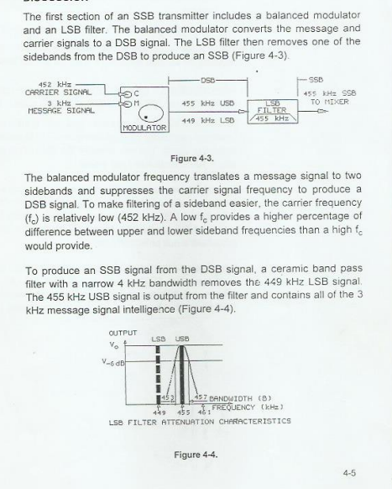

**Tasks (Exercise 1)**

**Procedure A: Balanced Modulator( Convert the Carrier and Message signal to DSB signal)**

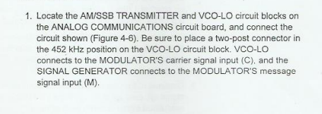

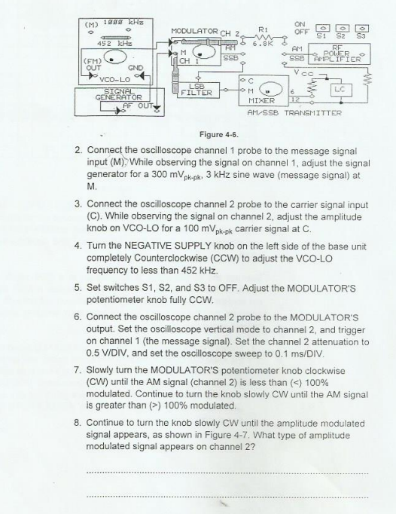

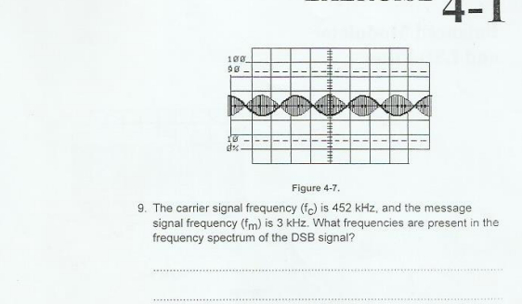

**Procedure B: LSB Filter (Produce an SSB signal by filtering LSB signal)**

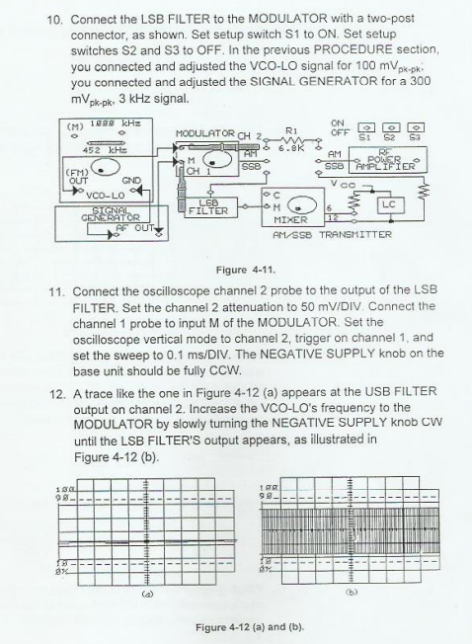

**Exercise (2): Mixer and RF Amplifier**

**Discussion:**

**Tasks(2)**

**Procedure A: Adjust the Circuit for a 455kHz to the MIXER**

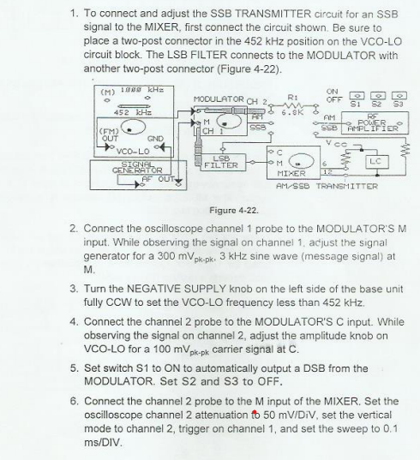

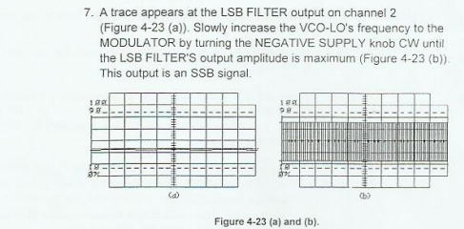

**Procedure B: Mixer: Convert the 455kHz SSB to a 1000kHz SSB**

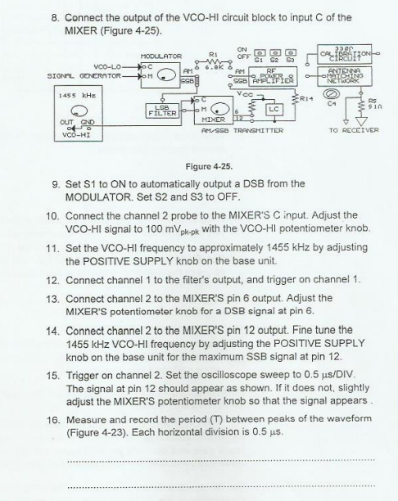

**Procedure C: RF Power Amplifier and Antenna Matching Network**



